Service Description (SD) Template

**Abstract**

The wm-data provider gets sensor data from an active windmill and provides a wm-data service where it then stores the data in the DataManager’s historian service.

## Service Description Overview

The wm-data provides one interface only

## Abstract Interfaces

Every interface should be described in a separate section. A more detailed description of the Overview section diagrams is suggested.

Every function included in the interface should also be presented and explained in a subsection for each interface. Sequence diagrams might be included to give a clearer view on functions’ usage.

The use of UML or SysML diagrams can be an adequate solution.

## Interface 1

This interfaces provides the requested sensor data from the windmill. When requested it takes the data from a FIFO queue and returns it to the requester.

## Function

Returns sensor data from the windmill.

## Sequence Diagrams

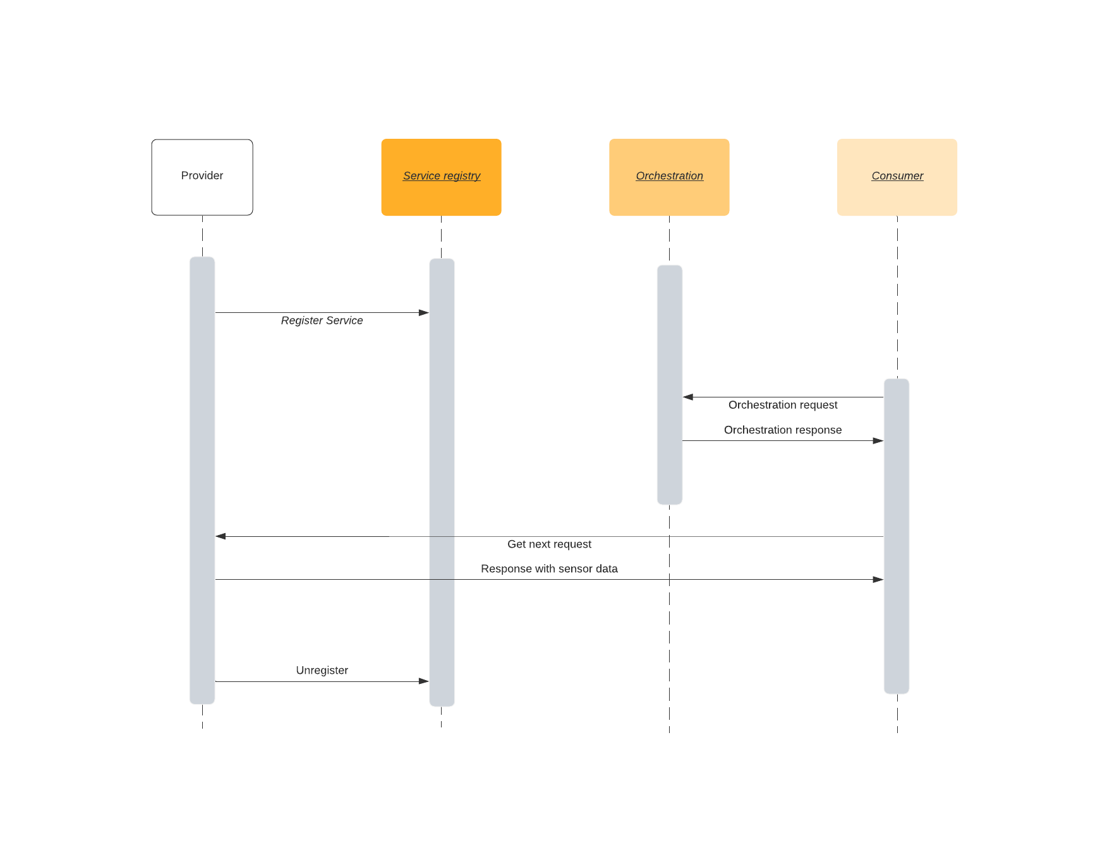

## Abstract Information Model

* Timestamp
  + In years since measurement started
  + Type: Double
* Speed
  + Revolutions per minute of the main rotor axle
  + Type: Double
* Acceleration
  + Time series Gs measured in the main rotor bearing
  + Type: double
  + Will be a collection of 16384 measurements for the given data point.

1. Non-functional Requirements

Describe requirements regarding QoS, response time, resources, reliability, etc. This section lists the non-functional requirements that can be implemented by the service. Note that some of these requirements can be optional.

This section reports, for example, the reliability targets that must be respected by the service in a particular use case. For example, a service can offer acknowledgment to service requests in a use case, and act on a best effort base in another use case.

The following table reports multiple non-functional requirements sets, each one pertaining to a use case that are directly implemented by the service.

**Table 3 Non-functional requirements description**

|  |  |  |  |  |
| --- | --- | --- | --- | --- |
| **Name** | **Description** | **Type** | **Constraints** | **Use**-**case** |
|  |  |  |  |  |

The above table must report the non-functional requirements, by providing information such as:

* **Name:** The unique name (UID) of the non-functional requirement.
* **Description:** A description of the non-functional requirement.
* **Type:** The type of the non-functional requirement (e.g., hardware, software, performance).
* **Constraints:** Any constraints the requirement imposes to the use-case(s) (e.g., have a delay of less than 1 ms to deliver the service).
* **Use-case:** Provide the ID of the use case(s) it refers to.

## References

Any references must be placed here

## Revision history

## Amendments

|  |  |  |  |  |
| --- | --- | --- | --- | --- |
| No. | Date | Version | Subject of Amendments | Author |
| 1 | 2020-05-27 | 4.1 | Major update | Jerker Delsing |
| 2 | 2020-08-17 | 4.2 | Major update | Jerker Delsing |
| 3 | 2020-0914 | 4.2.1 | Minor cleaning | jens Eliasson |
| 4 | 2021-01-25 | 4.3 | Added Windmill text | Robin Jonsson |

## Quality Assurance

|  |  |  |  |
| --- | --- | --- | --- |
| No. | Date | Version | Approved by |
| 1 | 2020-09-15 | 4.2.1 | Jerker Delsing |
| 2 |  |  |  |